Brooklyn torah gazette
Vayikra 5777
Volume 1, Issue 18 (Whole Number 18) 5 Nissan 5777/ April 1, 2017
Printed L’illuy nishmas Nechama bas R’ Noach, a”h

For a free subscription, please forward your request to keren18@juno.com

Gaining Inspiration from a Yerushalmi Rabbi
By David Bibi


Rabbi Shlomo Moshe Amar, former Rishon LeSion and current Chief Rabbi of Yerushalayim

As we enter Shabbat, I leave you with a very short thought on what we read this [past] Shabbat from The Rishon LeSion, Former Chief Rabbi of Israel and Chief Rabbi of Yerushalayim, Haham Shelomo Moshe Amar
Those of us in Manhattan had the privilege of spending the week with the Rabbi and his wife who each gave classes and interacted with the community. For me the highlight was last Shabbat. As we took out the Torah, I stood next to the rabbi and after we said Berich Shemeh, he gave a blessing that lasted for a few moments with a kavana that infused each word coming from the Rabbi’s heart.
I felt each word enter me and into my own heart. It was very strange and I later told Chantelle who was in Israel about the feeling. What was stranger was I felt at that moment that I truly needed a blessing, thought about it as we opened the ark and here Hashem through Rav Amar was answering me.
Rabbi Abittan, z’sl, always told us that we should never seek the blessing of those who travel from place to place and give blessings; rather we should strive to receive the blessing of a Torah Scholar. His voice always echoes within me and at that moment with the Hechal open and the Torahs in front of me, it resonated with each word from Rav Amar, a true Talmid Haham.
There is also something different about Rav Amar. He is physically a big man, but in his humility he is so unassuming. Rabbi Abittan told us that soon after Rav Amar became chief rabbi, Rabbi Abittan was in Israel and scheduled himself to pray with Rav Amar’s minyan. After a couple of days he asked someone when Rav Amar would be back. They laughed and pointed out Rav Amar who just mixed in as one of the people.
Rabbi Abittan was able to visit the Rishon LeSion in his home that Motsei Shabbat. The Rabbi brought his wife Ida, his son Meyer and daughter in law Debbie and some of their children. The Rabbanit made them tea. They waited for the Rabbi to do his Saturday night radio show and then spoke. I wonder if they spoke Hebrew, French or the special Moroccan Judaic Arabic. Whatever it was, the rabbi had fond memories of their Torah conversation for the rest of his life.
This past Sunday morning after Tefilah I have the feeling that Rav Amar delayed coming down to breakfast for twenty minutes so that I wouldn’t be uncomfortable in either not giving or giving a class in his presence. After the class ended and we said Kaddish the Rabbi appeared and we sat with him for a while. He is amazing at making others comfortable, asking questions about them and giving them his full attention. One can learn so much simply by observing the behavior of a Sadik.
As I understand he will be returning to Israel after this weekend. This morning I hoped to thank him, so after we finished our 6:30 minyan and our class, I went in to the next minyan to see him as that was when he was praying daily. To my dismay, he was not in the Synagogue. Disappointed, I left and figured I would send a note to someone in the synagogue to express my appreciation and wish the rabbi well.
I got in the car parked in front of the Synagogue, put my phone in the holder and dialed Moses in Jerusalem to wish him a Shabbat Shalom. It was nice to find Moses in my daughter’s apartment so I could speak to both of them. I turned down 5th Avenue and east onto 62nd Street and imagine my surprise, after passing Park Avenue to see the Rabbi emerging from one of the townhouses towards a car being escorted by Isaac Dabah.
I pointed out the rabbi to Moses using FaceTime, pulled my car over and ran to his car. Hopefully I didn’t startle him, and the rabbi opened the door and I was able to thank him in person and wish him a Shabbat Shalom. Another appearance of Hashem in coincidence; Heaven heard my wish and Heaven did not disappoint.
I leave you with a short note from Rav Amar and wish you a Shabbat Shalom and pray as we look forward to celebrating Nissan to the words of the Rabbis. In Nissan we were redeemed and in Nissan we will be redeemed.
“In this [last] Shabbat's Torah portions Vayakhel-Pekudei, we conclude Sefer Shemot which relates how we became a nation. The book of Shemot started out with describing the very beginning of our nation as slaves, working at hard labor under the harsh and cruel hand of the evil Pharaoh, who made the lives of Bnei Yisrael miserable through a brutal enslavement of both body and soul, along with horrible decrees.
“When the people cried out about their hardship, Hashem revealed himself to Moshe and sent him to salvage and rescue them from bondage to freedom, through signs and wonders and, "an outstretched arm." He then led us through dry land in the midst of the sea, and brought us close to Him, standing in front of Him on Har Sinai, where He revealed Himself to us, along with thunder and lightning flashes before the whole world.
“He chose us from all the nations and made us His treasured people, and as the first born of Hashem, He gave us His Torah; the Torah of truth and eternal life. Moreover, Hashem raised and exalted us above all other peoples and desired to dwell amongst us, since, "The heavens are his throne and the earth is his footstool," and He commanded us to take for Him an offering, and told us: "And they shall make Me a sanctuary and I will dwell in their midst."
“It is possible to say that Sefer Shemot is the book of the children - Bnei Yisrael. The book of Beresheet is called Sefer HaYahshar - "the Book of the Just" - since the "just" ways of our forefathers are recounted in it. Accordingly, Shemot is the book of Bnei Yisrael.
“This Shabbat is Shabbat HaHodesh in which we bless the upcoming month of Nisan, which is the "head" - the first - of all the other months. Even though we get a renewal to our souls every Rosh Hodesh, still the renewal of the month of Nisan surpasses that of all the other months, since it is the month of redemption, in which we were redeemed from Egypt, and in Nisan we are destined to be redeemed, as it says in the prophets: "
“As in the days of your exodus from the land of Egypt, I will show him wonders." Our firm trust is in Hashem, and our hope is steadfast, that soon Hashem will appear and his divine presence will be shown to 'Am Yisrael and He will rescue us mercifully for the second time in front of the eyes of the entire world, in happiness and in comfort.”
With fully hearted blessings,
Shabbat Shalom,
Rabbi Shelomo Moshe Amar

Reprinted from the March 24, 2017 email of “A Final Thought and Strange Coincidence from Shabbat Shalom from Cyberspace for Vayakhel-Pekudei 5777.”

On the Role of
A Jewish Woman
By Rabbi Avigdor Miller, Zt”l

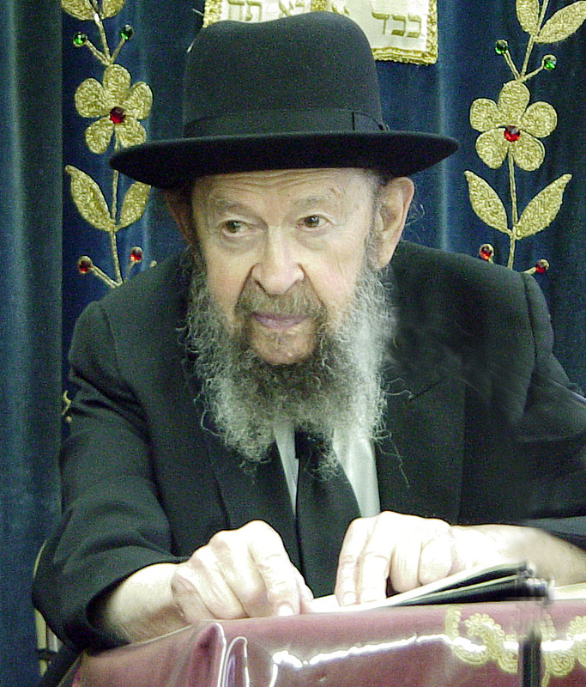

QUESTION: The Rav is always telling us that one of our greatest opportunities to become great is by learning גמרא and learning through ש"ס. So why doesn't the Rav encourage women to learn גמרא as well?
ANSWER: The answer is this. Women have an important function in the world which is not sufficiently emphasized. And that function is their perfection. And how do women gain perfection? By being mothers. Now, in this age, it's a forgotten art. The art of being a mother was once considered the acme, the summit, of a woman's שלימות, sheleimas - of her perfection.
Do you know what a woman has to go through to be a mother? I'm not talking about being a wife now. That's a separate perfection. But to be a mother, she has to tolerate every difficulty. She has to be patient. She has to bend her nature to conform to the circumstances. And that brings out in her nature all the hidden virtues. A fountain of kindlinless opens up in a woman that men don't have. Even when a woman begins to lactate, to have milk, at the same time the mother-love hormone is stimulated, together with the lactation. And that hormone is not merely an animal reaction. It awakens in her all the greatness of a human mother. And she can subsequently awaken a love for mankind - another form of Perfection - by practicing on her children, something that a man can never have. And so, an old woman who raised a big family - of course, if she did it l’sheim shomayim, (for the sake of heaven) then it's much better - she gains a שלימות (perfection) that is almost unequaled.
Now, it's impossible for a woman to labor in Torah while she's laboring bringing up a brood of children. Maybe you're thinking of a woman with one or two children, and then when they're out of the way, she wants to settle down to a lifetime of [learning] Gemara. Oh no! That's a very crippled picture. A woman who has time for anything but her children, is a woman who has failed in life. You have to understand that.
And I don't care what you'll say! A woman is expected to have as many children as humanly possible. And that's her greatness! That's her Shas (learning Gemara). It's more than a Shas. Every child is an entire Shas. And every child brings forth qualities that couldn't be brought forth in any other manner. So what are you asking? What are you trying to get her to do? You want her to sacrifice her greatness for something less?!!
A man must spend his time in Gemara. Otherwise, what do you need him for in this world? If he won't produce Torah and mitzvos, what do you need him for?
And therefore, it's like the bee and the cow, let's say. A cow has to produce milk and the bee produces honey and pollinates the flowers. They cannot exchange functions because each one was created with its specific function. You're not going to ask me why the bee is not giving milk!
Hakodosh Boruch Hu made men and women for different purposes in life. Men must leave their homes for hours to go to the places where they congregate to study Torah. Women can't go out at night. If they would go out, with whom would they leave their children? Their husbands?! It's impossible for a woman to pursue a lifetime of study! Men must sometimes leave their homes and travel to different cities to find teachers that are suited for them. A woman can't leave her children. And therefore, a woman is an entirely different person. Like the Gemara says, נשים עם בפני עצמן הן. Woman are a different nation than men. They are a separate nation. They have different kinds of characteristics and different kinds of perfection.
Now, there are some women who try to act like men. They want to become preachers and rabbis and teachers. And sometimes we need them too. Ok. But all of them are behaving like people who are masked. It’s not their true nature. It's not their true perfection.
Home! That is the Yeshiva, that is the Mesivta, that is the place of success for a woman. (TAPE # 430.)

Reprinted from the March 25, 2017 email of Toras Avigdor.

Shloshim for Mrs. Breindy Reiss, A”H
By Rabbi Moshe Meir Weiss

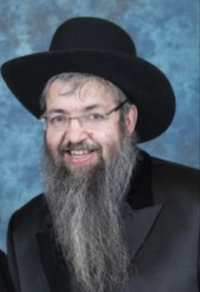

The tragic sudden passing on 9 Adar, 5777 of our sister, mother, aunt, sister in law, and bubby, Breindel Yocheved bas R’ Aharon (Mrs. Breindy [nee Gelbtuch] Reiss a”h) is heartbreaking!
Breindy embodied so many difficult life challenges and tried her utmost to rise above them. She was an isha chashuva who impacted so many people, old and young, from all different walks of life and influenced them. She never stopped learning and growing.
Breindy was a prolific writer and speaker. She was an esteemed writer for Hamodia, the Jewish Press, the Jewish Connection, The Schmuz, etc., often under a pseudonym. She wrote on various topics such as the Torah’s source for covering one’s hair, texting on Shabbos, and book reviews such as one for her brother in-law’s “Power Bentching.” On many occasions she addressed the crowd who came to partake in a Chinese auction for the benefit of the Zichron Shlomo Fund held annually in Staten Island and was a guest speaker in various Bais Yaakov high schools.
Breindy started her teaching career after graduating in 1973 from Rebbetzin. B. David’s Seminary Program on the Lower East Side of Manhattan where she and her Gelbtuch sisters grew up. She began teaching at Breuer’s High School and then went on to teach at T.A.G., Yeshiva of Brooklyn (for over two decades) , Tomer Devora, Bais Yaakov of Brooklyn, Ohel Sarah, and then onto Bais Rochel of Williamsburg where she taught creative English writing.
She was incredibly affectionate and truly respected by all her talmidos. Breindy was a great admirer of Rav Avigdor Miller, Zt”l, and enjoyed listening to his tapes on so many varied topics. Breindy was on an exceedingly high level in her emunah in Hakadosh Baruch Hu and her love of Torah was boundless.
For over 40 years, she would prepare her lessons and was asked by so many people, “Didn’t you prepare enough all these years? Why are you still preparing your lessons?” Her answer was, “I need to refresh my memory and delve into the topic even further so as to be better prepared to answer any new questions that may arise from my students.”
For many years, Breindy gave shiurim on Shabbosim on the Parsha/Navi in many shuls. For a span of 20 years, she held a weekly class in her home and taught Tanach and every year a different sefer was reviewed. A trained grants researcher, she was also licensed taharas hamishapacha teacher. She was an artist, as well, and painted in her free time. Breindy always approached daas Torah for her sheilos, always wanting to do the correct thing. She had such tremendous yiras shamayim.
When Breindy taught the 39 melachos, she brought the classes to life to her students by bringing in all kinds of paraphernalia from her kitchen so the students would have a “hands on” experience in studying what was permitted or prohibited on Shabbos and Yom Tov.
Even in the darkest of times throughout the generations, Klal Yisrael has turned to reciting tehillim and so, too, Breindy always reached out to recite perakim in Tehillim. What is so beautiful about this Sefer Tehillim that Klal Yisrael has turned to it throughout the doros/generations?
Dovid HaMelech sings “Mizmor L’David…Hashem roi lo echsar.” In the midst of his songs and praise to Hashem, Dovid alludes to his own suffering. “Gam ki eilech bigei tzalmaves lo ira ra, ki Ata imadi – Even if I walk in the shadow of death I will not fear because You are with me.” “Shivtacha umishantecha heima yinachamuni – Your rod and staff shall comfort me.”
Says Rashi – shivticha: the suffering that I endured, is from You. That is a nechama/comfort in itself knowing that my suffering is from Hakadosh Baruch Hu and not from any outside source.
That is the nechama that Dovid HaMelech believed. That was his bitachon/trust in Hashem. The other part of his nechama was umishanetecha. Says the Radak: Lulei Sorasacha shaashua az avaditi bioni.” That is the Torah that Dovid HaMelech acquired. His Torah was his toy just as children love to play with toys. These were the two aspects that gave comfort to him in those years of darkness. “Shivitacha umishantecha heima yinachamuni.”
Dovid Hamelech absorbed the shivticha no matter how much the pain was and at the same time was able to immerse himself in mishantecha – the world of Torah upon which the universe continues to exist.
Knowing that she suffered and had difficulties in life but always had the Torah alongside her, Breindy was able to continue to serve Hashem until He decided to take her neshama to a higher level.
Breindy will be sorely missed by her family and the thousands of talmidos she taught and dedicated herself to for a span of over 40 years.
May she be a melitzas yosher for the family and for Klal Yisrael.
Yihi Zichra Baruch!

Reprinted from the March 29, 2017 website of The Vues.

Making Sacrifices
For Our Children
By Rabbi Eli J. Mansour



Ironically, there are many Jewish schools that omit the Book of Vayikra from their curriculum, figuring that it is too detailed, intricate and difficult for their students. These schools would rather focus their attention on the exciting stories of the Torah, rather than burden the students with the complex laws of the sacrifices.
This is ironic because the Midrash records a tradition to do just the opposite – to make Vayikra the first section of Humash that schoolchildren are taught. The Midrash writes, “Let the pure ones come and study that which is pure.” According to this tradition, the best introduction to the world of Torah study for children is precisely the subjects of Vayikra.
Why would the Book of Vayikra be the first section of Humash taught to children?
One explanation might be that the study of Vayikra sends a powerful message not to the children – but to their parents. Communities adopted this custom because they wanted the schoolchildren to return home and report to their parents that they learned about sacrifices.
One of the critical foundations of Torah education is sacrifice. Parents must make enormous sacrifices to provide their children with a proper Torah education. Tuition expenses require parents to work long hours and to forego on luxuries. Without doubt, the cost of Jewish education causes many families to live on a much lower standard of living than they would otherwise enjoy. Appropriately, then, the very first subject children were taught was sacrifices –conveying to parents the message that they must be prepared to make significant sacrifices for the sake of their children’s education.
The story is told of a family in early 20th-century Poland that was struggling to make ends meet. The father decided that the family should relocate to the United States where he could open a business and support the family more comfortably than he could in Poland. He sailed to the United States to open a business and get settled, planning to bring his family over after his initial arrangements were completed.
Unfortunately, World War I erupted while he was in America, and international travel was brought to a halt. As a result of the war’s upheavals, the family was separated for ten years. During this time, the wife worked very hard to support herself and her two children, and to pay for their Torah education.
One day, she was notified that one of her sons was a child prodigy and has the potential to become a leading Torah scholar. The school informed the mother that the child’s level far exceeded that of the other students, and she would have to hire private tutors to study with him so he could realize his potential. The mother promptly took on a nighttime job delivering milk. After a full day of work and caring for her children, when the children were in bed, she would go around town delivering milk in order to earn some extra money for her son’s tutors.
Her efforts paid off. That boy grew to become Rav Chaim Pinchas Scheinberg, one of our generation’s leading Torah sages. One can only wonder whether he would have attained this stature without the monumental sacrifices made by his mother on behalf of his education.
In order to educate our children, we must be prepared to make significant sacrifices. Besides the financial sacrifices, we might have to forego on certain activities for the sake of our children’s spiritual growth. Parents might enjoy watching television, but they need to consider the harmful effects a television could have on their children.
Parents certainly deserve a luxurious family vacation, but many vacation spots must be labeled as off-limits because of what the children might be exposed to at these locations. We can’t have our cake and eat it, too. If we want our children to grow to become committed, conscientious Jewish adults, we have no choice but to make sacrifices for their education.
The Torah says that as Abraham prepared to sacrifice his son at the Akeda, an angel called to him “from the heavens” and commanded him to withdraw his sword (Bereshit 22:11). Curiously, the angel did not descend to Abraham and speak to him on earth, but rather called to him from the heavens. Rav Moshe Siman-Tov explained that the area around Abraham Abinu at that moment was so sacred, that even the angels could not approach him.
When a parent makes a great sacrifice for the sake of his or her children, this sacrifice generates intense Kedusha. Abraham was prepared to make the ultimate sacrifice, and thus he generated such a high level of sanctity that even the angels had to keep their distance. This is a crucial message that parents must remember at all times. Every time a parent writes out a check for the child’s education, this creates Kedusha.
Every time parents decide against purchasing a luxury item so they can afford their tuition payments, they generate more holiness. And every time parents scratch an idea for vacation out of concern for their children’s spiritual wellbeing, they produce sanctity.
This is one of the fundamental lessons of Vayikra. Torah education requires sacrifice. As parents, we must accept this basic truth and be prepared to make sacrifices for our children’s growth. Indeed, education begins with Vayikra – with the awareness of the central role of sacrifice in the educational process.

Reprinted from this week’s website of The Edmond J Safra Synagogue with Rabbi Eli J. Mansour.
In Brooklyn’s Kosher Pizza War, Modern Tastes
Battle Ancient Law
By Corey Kilgannon, March 28, 2017


Basil Pizza & Wine Bar, left, and Calabria, right, brought their civil dispute before a rabbinical court in Brooklyn. (Photo Credit - Joshua Bright for The New York Times)

In a city as pizza-crazed as New York, pizza wars erupt with some regularity, from dollar slice joints battling for customers in Manhattan to a Mafia-tinted dispute over a stolen sauce recipe between a pizza shop in Brooklyn and another on Staten Island.
But perhaps nothing compares to a kosher pizza war, pitting 21st-century foodie-ism against the decidedly 19th-century world of an insular Hasidic neighborhood.
Two pizza restaurant owners, both orthodox Jews, have become entangled in an only-in-Brooklyn lawsuit, not in an august courthouse, but in an obscure hall of justice known as the Rabbinical Court of Borough Park, which hears cases in a simple room above a synagogue on a residential block.
At the center of the battle are not prices or sauce recipes, but cryptic interpretations of holy law set down in ancient Aramaic thousands of years ago. Both sides have invoked rules dictated by the Torah and the Talmud, as well as a cookbook’s worth of interpretations of kosher rules and certification standards.


Calabria, which opened last month across the street from Basil, has customers order at a counter. (Photo Credit - Joshua Bright for The New York Times)

Armed with their arguments, the two pizza sellers appeared last month in rabbinical court, known as a beth din. There, things proceeded like a Hasidic People’s Court, with the judges — three rabbis — dressed in traditional all-black garb, facing the litigants.
At one table, the plaintiff: Daniel Branover, an owner of Basil Pizza & Wine Bar, a popular upscale kosher restaurant in Crown Heights that opened in 2010 and offers specialty pies as a menu staple.
At another table, the defendant: Shemi Harel, who this month opened Calabria, a pizza shop directly across the street from Basil.
With its graffiti-style décor and casual, pay-at-the-counter dining, Calabria is very different from sleek, modern Basil, where weekend diners often wait two hours for a table.
But it was Calabria’s menu that set off alarms for Mr. Branover, whose customers pay as much as $24 for individual pies.


A mural at Calabria, the more casual of the two pizza restaurants. (Photo Credit - Joshua Bright for The New York Times)

Mr. Branover took one look and saw a threat to his thin-crust, sauce-laden business plan: Calabria was offering a similar product at a lower price, mere steps away.
“I just couldn’t look the other way,” Mr. Branover said. “He didn’t want his customers. He wanted my customers.”
While some may see this as mere capitalism, Mr. Branover considered it a violation of Talmudic law on unfair competition by a new, nearby business — in Hebrew, “hasagat gevul.”
So he sued in rabbinical court, claiming a case of “one business hurting the livelihood of another business.”
Mr. Branover said he had helped transform dining in the neighborhood by opening Basil, where Hasidics, local Caribbean immigrants and newly arrived professionals could mix over good kosher food. Now here was this upstart interloper encroaching on his business.
“They did everything that was against Jewish code, and that’s the reason I went after them,” said Mr. Branover, whose partner at Basil, Clara Perez, said that Calabria’s owners had stealthily debriefed employees about Basil’s most popular pizzas and how to make them. She also accused Calabria’s owners of poaching customers while they waited outside for Basil’s tables to clear.

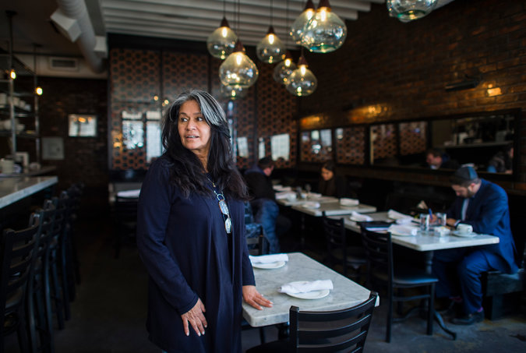
Clara Perez, a partner at Basil, claimed that Calabria tried to copy Basil’s recipes and poach its customers. (Photo Credit - Joshua Bright for The New York Times)

Mr. Harel dismissed the accusations as nonsense, saying that his restaurant’s look, menu and pizza were clearly quite different from Basil’s.
The case provides a window into a merchants’ dispute rarely heard in rabbinical courts, vestiges of a religious legal system established in ancient times and prevalent today in Orthodox communities as an alternative to the civil court system.
Beth dins are better known for mediating and adjudicating religious bills of divorce, kosher certifications and conversions to Judaism. But, on occasion, they also rule on more enigmatic points of Jewish law, such as claims of ruinous competition.
In 2006, a State Supreme Court ruling upheld a rabbinical court decision blocking one Hasidic-owned bus company from copying another’s route schedule from New York to Washington. And in 1993, a group of kosher restaurants in Teaneck, N.J., asked a rabbinical court to stop a nearby restaurant from expanding and stealing its customers.
The pizza ruling was issued in mere days, in Hebrew, with certain citations of the Torah and the Talmud in ancient Aramaic.
The rabbis sided largely with Mr. Branover, finding that Calabria was so close both geographically and in food style that it jeopardized Basil’s livelihood. Calabria was told to switch to offering “regular pizza,” which the court defined as “New York-style pizza,” though it did not provide any further guidance.
Each morning, get the latest on New York businesses, arts, sports, dining, style and more.
Since the ruling, however, the case has fallen into a murky divide between ancient Talmudic law and the conventions of a classic New York slice.
To Mr. Branover, the ruling means Calabria must stick to basic pizza parlor rules: round pies, sliced into wedges.
Mr. Harel called the ruling unfair and mystifying. He said it would hinder his pursuit of the top kosher certification, critical to attracting customers.
To follow the court’s New York-style pizza edict, Mr. Harel said, he searched online for the best dough recipe that fit the bill. He quickly revised Calabria’s website to call its pizza “New York-style.”
But he continued to sell rectangular slices.
Mr. Branover accused Calabria of making nominal changes in a cynical attempt to flout the ruling. He is prepared, he said, to file a civil suit, using the rabbis’ ruling as leverage.
Mr. Harel said Calabria was a family business that cost “in the high six figures” to open and had required a sizable loan. Mr. Branover said that of his annual gross sales of roughly $3 million, pizza sales accounted for roughly $50,000 a month, but that pizza was his biggest attraction for customers.
In an interview, the rabbis who heard the pizza case said they had considered Calabria’s location, as well as Mr. Branover’s substantial investment in his restaurant and the reputation it had won.
While Jewish law does not oppose competition as a rule, “there were exceptional circumstances unique to this case, including the similarities in appearance and concept” in pizza offerings, said Rabbi Reuven Alt, the senior member of the Borough Park panel.
Like many rabbinical courts, the Borough Park panel is set up like a simple civil courtroom, akin to a traffic court in that it has no gallery, bailiffs or court reporter.
Cases have plaintiffs and defendants, and proceed in Hebrew, with witnesses, evidence presentations, questions from the rabbis and cross-examinations.
In the pizza case, the rabbis took the unusual step of visiting the restaurants, using an Uber car to drive them there.
“These are not people who hang around restaurants, but they got into the nuances of the different ovens and atmosphere,” Mr. Branover said. “They really did their homework.”
Mr. Harel said that Jewish law regarding competition applies only to merchants in the same profession, and that this case is different because Mr. Branover owns a profitable energy management company, Satec.
“It’s not his business, it’s his hobby,” said Mr. Harel, 28. He called Mr. Branover a wealthy man “who got his ego hurt, and I’m a young man doing the only thing I know how to do.”
Mr. Branover said, “It doesn’t matter how much money I have, the law applies to the business, not the businessman.”
Calabria, Mr. Harel said, has become a hit with customers because of things no one could contest in any court.
“The place is clean, and service is superb, and the ingredients are the freshest,” he said. “Nobody has a patent on that.”

Reprinted from the March 28, 2017 website of The New York Times. The story was first covered in the March 13, 2017 edition of The Forward by Michelle Honig under the headline: “Kosher Pizza War Erupts in Hasidic Brooklyn – And Jewish Court Slices the Pie.”

